Lab: Understand Docker Networking
In this lab, you will practice using Docker’s default bridge network and the host network. You’ll run containers in each network mode, use Docker commands to observe their networking, and verify how connectivity works in each case.

Listing Docker’s Default Networks

List the default networks:
docker network ls

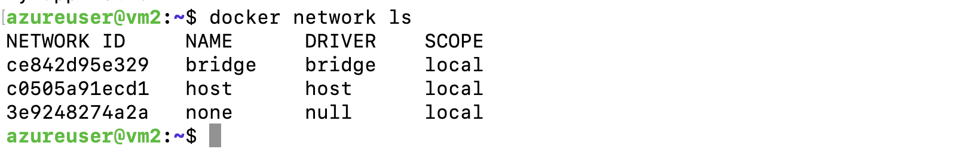
Docker creates these networks on install.
The default bridge network uses the bridge driver (containers get a private subnet and connect through a Linux bridge), while the host network isn’t an isolated network at all – it shares the host’s own network stack.
Inspect the bridge network :
To see details of the default bridge, run
docker network inspect bridge
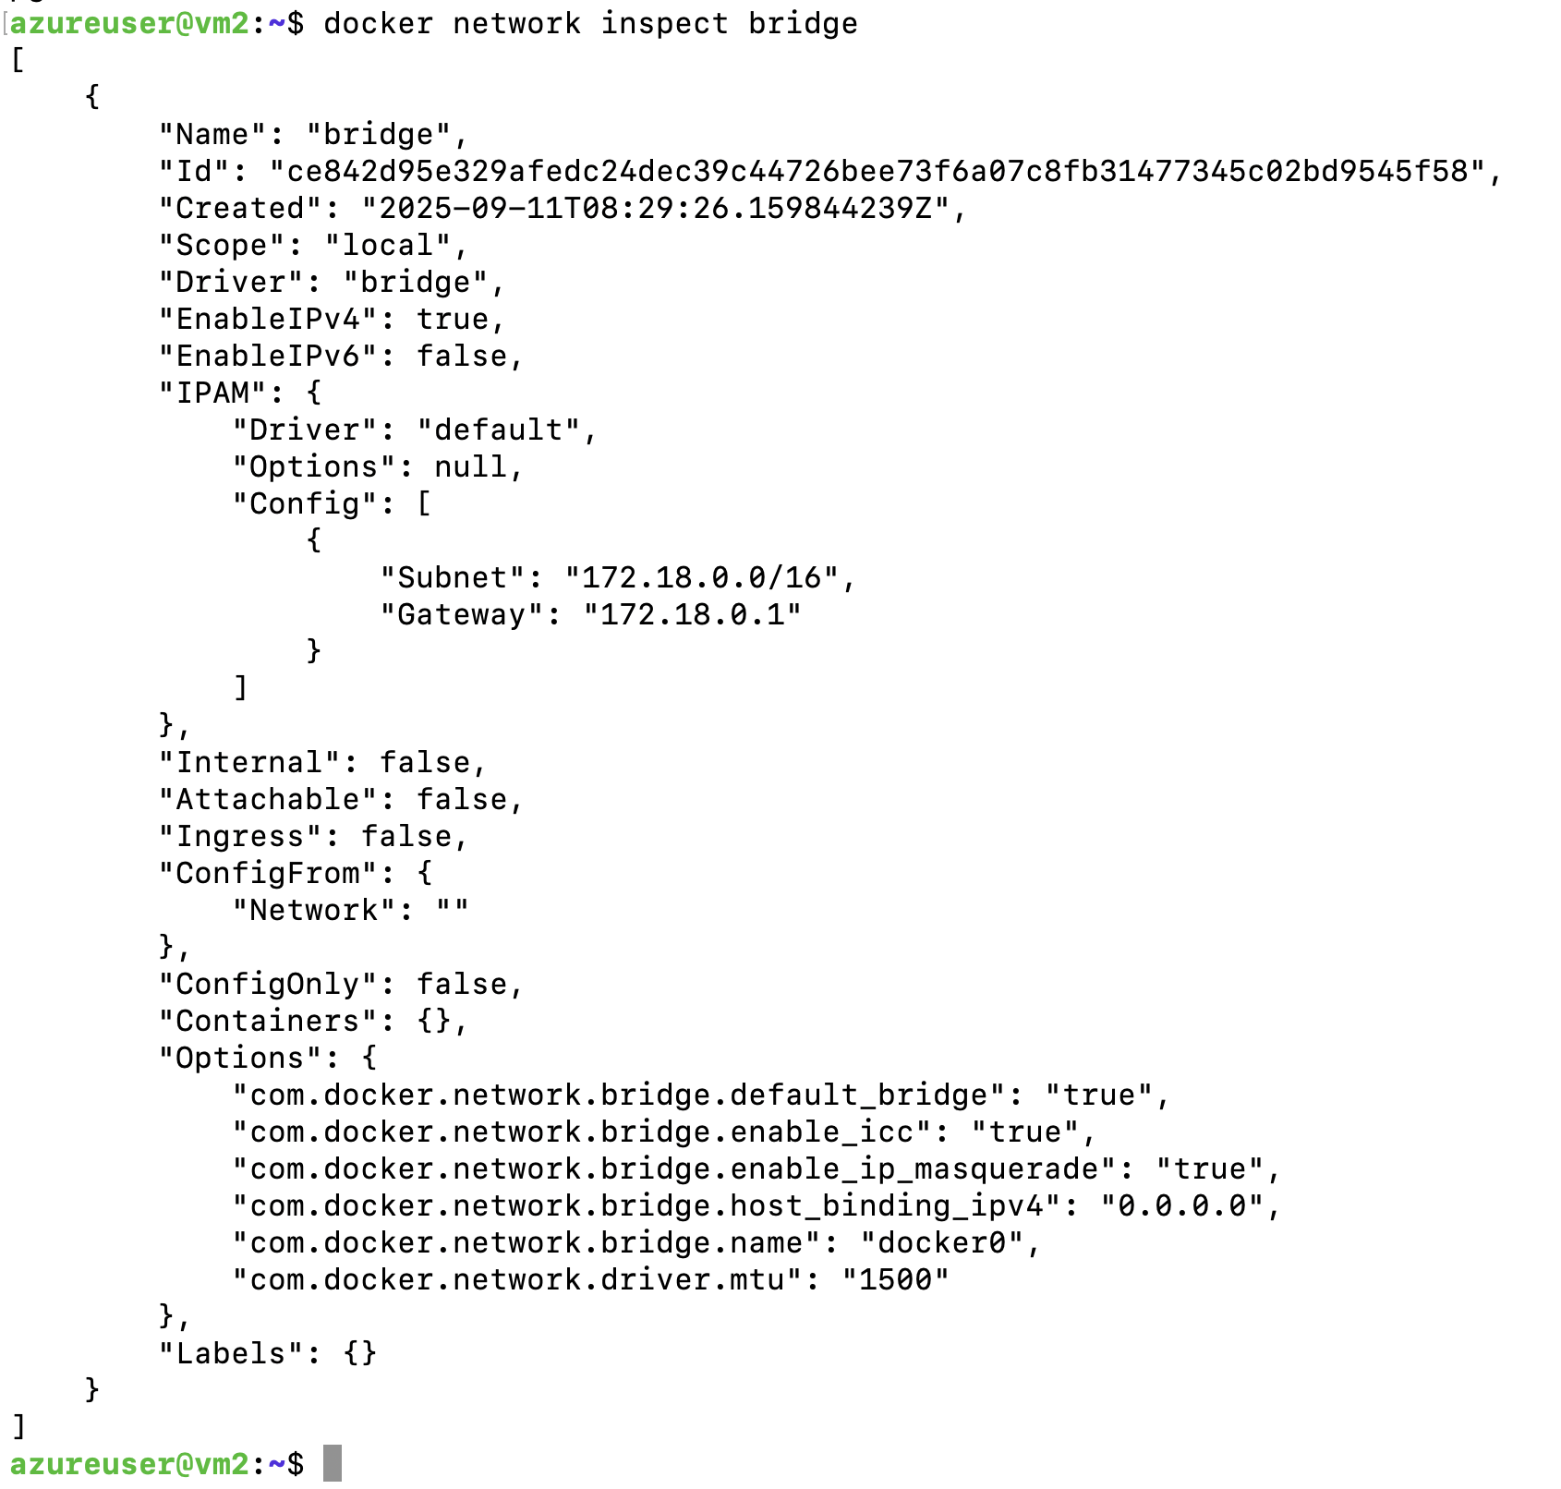
Look for the subnet and gateway.
By default, Docker’s bridge network uses the subnet 172.17.0.0/16 with gateway 172.17.0.1 on the host’s docker0 interface.
No containers are attached yet (the "Containers": {} section will be empty).
This confirms the bridge is a private internal network for containers, using NAT (IP masquerading) to reach outside networks.

Using the Bridge Network (default Docker network)
By default, Docker containers run in the bridge network if no other network is specified.
In this mode, each container gets its own IP address in the bridge network and is isolated from the host network.
You’ll start a web server container and see how networking works in bridge mode.
Run a container on the bridge network: Start an NGINX container (web server) without publishing any ports:

docker run -d --name webserver nginx
This launches an NGINX container attached to the default bridge network.
Attempt to access the web service: On your host, try to reach the NGINX server via localhost:
curl http://localhost
This will fail or time out, because the container’s web server isn’t accessible on the host’s network when running in bridge mode (no port was published).
The container’s port 80 is only accessible inside the Docker bridge network.
In bridge mode, containers have their own private IP and are invisible on host ports unless you explicitly publish them.
Find the container’s IP : Run an inspect to see the container’s IP address on the bridge network:
docker inspect -f '{{range.NetworkSettings.Networks}}{{.IPAddress}}{{end}}' webserver

Your container will have an IP in the 172.17.0.0/16 range.
This is the private address Docker assigned on the bridge network. The host can reach this IP (for example, you could ping it from the host), but it’s not routable from outside the host.
This confirms the isolation: the container is using a separate network namespace with its own IP, communicating out through the host’s docker0 bridge and NAT.
Expose the container to the host network: Stop and remove the webserver container (or open a second terminal) and run a new NGINX container with a port mapping:
docker rm -f webserver # remove the previous container if still running

docker run -d --name webserver2 -p 8080:80 nginx
Here -p 8080:80 publishes the container’s port 80 to 8080 on the host.
Docker sets up a NAT rule so that any traffic to host port 8080 is forwarded to port 80 in the container. Verify the container is running with docker ps and note the PORTS column now shows 0.0.0.0:8080->80/tcp. This mapping tells us that port 8080 on the host is linked to port 80 in the container.
Verify access via published port: Now curl the NGINX through the mapped port:

curl http://localhost:8080

<!DOCTYPE html>
<html>
<head><title>Welcome to nginx!</title></head>
...
<p><em>Thank you for using nginx.</em></p>
</body></html>
You should see the HTML from NGINX’s welcome page. This confirms the port mapping worked – the web service in the container is reachable via the host’s port 8080.
In general, to make a container’s service accessible from the host or external network, you must publish its port with -p (port mapping) when using the bridge driver. If you try a port that wasn’t published (for example, host port 80 in this case), it will not connect, demonstrating the isolation provided by bridge networking.

Using the Host Network
In host network mode, Docker does not provide a separate IP or network namespace for the container – the container shares the host’s network directly.
Run a container in host network mode: Start another NGINX container, this time on the host network:
docker run -d --name hostweb --network host nginx
Docker will run the container attached directly to the host’s network. You won’t see a new network interface or subnet for this container – it uses the host’s network interfaces.
- Verify the container is running: Use docker ps to confirm hostweb is up. The PORTS column may be blank (or show the container’s port 80 with no mapping). This is expected – in host mode Docker doesn’t need to map ports. The NGINX process inside the container is bound to port 80 on the host’s network interface.
- Test the service on host network: Curl the host’s address (or localhost) on port 80:
curl http://localhost

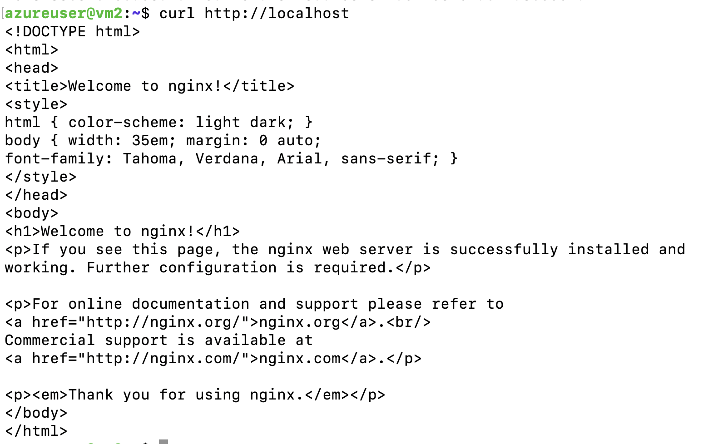
This time, you requested localhost:80 without any -p port mapping on the container.
The container’s web server was accessible because, in host mode, the container’s application is available on the host’s IP address using the same port.
Essentially, the NGINX inside the container is bound directly to the host’s port 80.
Inspect the container’s network settings: Check the container’s IP address setting with an inspect command:
docker inspect -f '{{.NetworkSettings.IPAddress}}' hostweb
This will likely return an empty string. In host mode, the container does not have its own Docker-assigned IP (IPAddress shows as blank).
It’s using the host’s network namespace, so it shares the host’s IP. This confirms the host network driver gives no separate network identity to the container.

Cleanup
After the lab, stop and remove the containers you started to free resources and avoid port conflicts:
$ docker container stop webserver2 hostweb
$ docker container rm webserver2 hostweb

